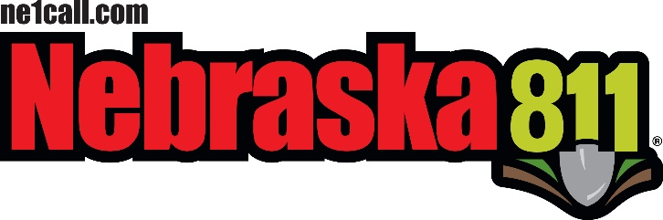
STATEWIDE ONE-CALL NOTIFICATION CENTER
BOARD OF DIRECTORS BOARD MEETING AGENDA

October 17, 2019
Location:
Country Inn and Suites
5353 N 27th Street
Lincoln, Ne. 68521
Committee Meetings: 9:00 am Board meeting: 10:00 am

- Call Meeting to Order
  - Housekeeping -
  - Meeting Notice posted –
  - On the Web –
  - Announcements -

- Roll Call

- Introductions
  - Guest’s introductions

- Approval of Meeting Agenda

- Approval of Minutes of the previous Meeting
  - August 21, 2019 board meeting

- Public Comment – (15 minutes -Questions or concerns for the board)

- Committee Reports
  - Policy Committee
    - Dave S.
    - ACTION ITEMS:

    - Legislature Committee – Andy

    - ACTION ITEMS:

  - Advertising Committee – Jerry
    - ACTION ITEMS:
      - TBD

  - Bylaws Committee – Stan Waterman /

    - ACTION ITEMS:
      - Updating after Rule and Reg Chapter 1 & 2 are in effect.

  - Best Practices committee - Dan M. /

    - ACTION ITEMS:

  - New Technology committee – Lance / Val / John

    - ACTION ITEMS:

- DPRC Center Report
  - DPRC Status Report – Tyler
  - Outreach Report – Jill
  - Questions for Jill

    - ACTION ITEMS:
    - TBD

- Treasurer’s Report – John
  - John’s Report
  - Approval of the Treasurer’s Report
  - Questions / Concerns

  - ACTION ITEMS:
    - TBD

- State Fire Marshal’s Report
  - David’s Report & Updates –
  - Kevin’s Report and Meeting updates for 2019
  - Regina’s Updates –
  - Correction of Grant funding – Val
    - State Fair Lessons learned – David and Kevin
    - Educating Stake holders – David, Kevin and Board
  - Questions / Concerns for David, Kevin or Regina

  - ACTION ITEMS:

- Non-Compliance Report – Ne. AG’s Office
  - Report from NE. State Fire Marshal’s Office

  - ACTION ITEMS:
    - TBD

- Old Business
- OCC Conference in Portland –

Those attending the OCC Tech Conference
- Action / Follow up Items
- • Second round of rule/reg changes - Dave
• BOD Insurance review-Lance
• Line item in 2020 budget for map data – (December agenda) - Jill
• Manual changes – committee to draft - Jill, Dave, SFM reps, John, Dan,

Tyler
• Meeting with Senators - Regina
• Fall Stakeholder meetings – Jill, Val
• Tutorial videos for Next Gen/ InSite /LTM - Tyler
• Meeting with AG to determine alternatives to dispute resolution board –

Regina, John, Dave, BJ, other board members
• Public Comment location on agenda - Val
• Combined damage/incorrect locate tickets – Dave, Tyler
• Requiring counties to provide map data – not assigned

- New Business

- Damage / In Correct / Miss Locate Tickets
- Damaged UG facility – Miss Locate or Damage Ticket

- Failure to locate – What can be done?

- Failure to respond to a No Response Notice – What can be done?

- Do you understand the new Rules and Reg.s’?

- Who should have the final answer on interpretations on a Statue?

- ACTION ITEMS:

- Common Ground of Nebraska Report
- CGN Updates –
  - Abandoned UG Facilities
- 2020 Underground Safety Summit -
- Next CGN Meeting –

- Closing Comments from the Board Chair

One message / the same message

  - Next meeting date and site – December 5th in Lincoln @ Country Inn

- Adjournment

The public may request that items be added to the Agenda if such requests are received 24 Hours prior to any scheduled meeting. Requests must be in writing and directed to:

Val Snyder, NE811 Board Chairperson; 3808 28th Ave. Suite B. Kearney, Nebraska 68845
Or

E Mail to – val.snyder@tallgrassenergylp.com

